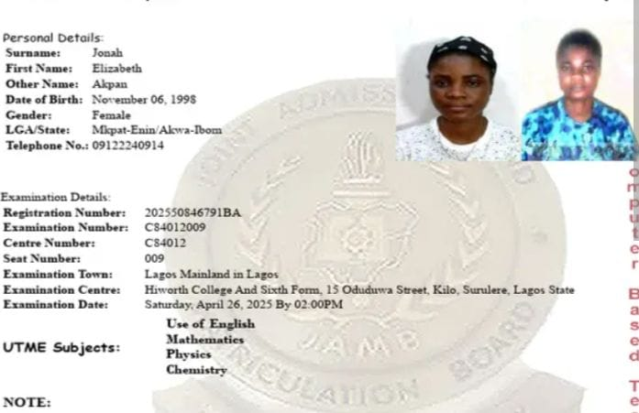
USE OF ENGLISH LANGUAGE
1. The smallest particle of an element that retains its chemical properties is:
A. Atom
B. Molecule
C. Ion
D. Compound
2. The atomic number of an element represents the number of:
A. Neutrons
B. Protons
C. Electrons and neutrons
D. Protons and neutrons
3. Isotopes of an element have the same:
A. Mass number
B. Number of neutrons
C. Atomic number
D. Atomic mass
4. Which of the following is a compound?
A. Oxygen
B. Hydrogen
C. Sodium chloride
D. Iron
5. The formula for methane is:
A. CH₃
B. CH₄
C. C₂H₆
D. CO₂
6. The process by which a solid changes directly to gas is called:
A. Evaporation
B. Condensation
C. Sublimation
D. Melting
7. Which of the following increases the rate of evaporation?
A. Low temperature
B. High humidity
C. Large surface area
D. High pressure
8. The kinetic theory states that particles in a gas move:
A. Slowly
B. Randomly
C. In circles
D. Not at all
9. The boiling point of a liquid depends on:
A. External pressure
B. Colour
C. Shape
D. Size
10. Diffusion is fastest in:
A. Solids
B. Liquids
C. Gases
D. Plasma
11. Elements in the same group have the same number of:
A. Shells
B. Valence electrons
C. Neutrons
D. Protons
12. The most reactive group of metals is:
A. Group I
B. Group II
C. Group VII
D. Group 0
13. Chlorine belongs to which group?
A. Group I
B. Group VII
C. Group II
D. Group 0
14. Noble gases are chemically:
A. Very reactive
B. Reactive
C. Inert
D. Metallic
15. Atomic size decreases across a period because:
A. Nuclear charge increases
B. Shielding increases
C. Mass increases
D. Protons decrease
16. Ionic bonding involves transfer of:
A. Protons
B. Neutrons
C. Electrons
D. Atoms
17. Covalent bonding involves:
A. Sharing of electrons
B. Transfer of protons
C. Loss of neutrons
D. Breaking of atoms
18. Which compound is ionic?
A. CO₂
B. HCl
C. NaCl
D. NH₃
19. A double bond consists of how many shared electron pairs?
A. One
B. Two
C. Three
D. Four
20. The shape of methane is:
A. Linear
B. Trigonal planar
C. Tetrahedral
D. Octahedral
21. One mole of a substance contains:
A. 6.02 × 10²³ particles
B. 6.02 × 10²² particles
C. 6.02 × 10²¹ particles
D. 6.02 × 10²⁰ particless
22. The molar mass of H₂O is:
A. 16 g/mol
B. 17 g/mol
C. 18 g/mol
D. 20 g/mol
23. Relative atomic mass of carbon is:
A. 10
B. 12
C. 14
D. 16
24. The empirical formula of C₂H₄ is:
A. CH
B. CH₂
C. C₂H₂
D. C₂H₄
25. At STP, one mole of gas occupies:
A. 22.4 dm³
B. 24.0 dm³
C. 20.0 dm³
D. 18.0 dm³
26. A substance that produces H⁺ in solution is a:
A. Base
B. Salt
C. Acid
D. Metal
27. The pH of a neutral solution is:
A. 1
B. 7
C. 14
D. 10
28. Which of the following is a base?
A. HCl
B. NaOH
C. H₂SO₄
D. HNO₃
29. Blue litmus turns red in:
A. Base
B. Neutral solution
C. Acid
D. Salt
30. A salt is formed from:
A. Metal + oxygen
B. Acid + base
C. Gas + gas
D. Metal only
31. Oxidation involves:
A. Gain of electrons
B. Loss of electrons
C. Gain of protons
D. Loss of neutrons
32. Reduction involves:
A. Loss of electrons
B. Gain of electrons
C. Loss of oxygen
D. Gain of hydrogen only
33. An electrolyte conducts electricity because it contains:
A. Molecules
B. Atoms
C. Ions
D. Neutrons
34. Rusting of iron requires:
A. Oxygen only
B. Water only
C. Oxygen and water
D. Nitrogen
35. The positive electrode in electrolysis is the:
A. Cathode
B. Anode
C. Cell
D. Ion
36. Alkanes are:
A. Saturated hydrocarbons
B. Unsaturated hydrocarbons
C. Aromatic compounds
D. Alcohols
37. The general formula of alkanes is:
A. CnH2n
B. CnH2n+2
C. CnH2n-2
D. CnHn
38. Ethene belongs to the:
A. Alkane family
B. Alkene family
C. Alkyne family
D. Alcohol family
39. Fermentation produces:
A. Methane
B. Ethanol
C. Propane
D. Butane
40. Benzene is an example of a:
A. Saturated compound
B. Aromatic compound
C. Alkane
D. Alcohol
41. Hard water contains high amounts of:
A. Sodium ions
B. Calcium ions
C. Chloride ions
D. Hydrogen ions
42. The process of removing temporary hardness is called:
A. Filtration
B. Distillation
C. Boiling
D. Crystallization
43. A catalyst works by:
A. Increasing activation energy
B. Decreasing activation energy
C. Changing products
D. Being consumed
44. Haber process is used to manufacture:
A. Ammonia
B. Sulphuric acid
C. Nitric acid
D. Sodium hydroxide
45. Contact process produces:
A. NH₃
B. H₂SO₄
C. HNO₃
D. NaCl
46. Radioactivity was discovered by:
A. Dalton
B. Rutherford
C. Becquerel
D. Bohr
47. Alpha particles carry a charge of:
A. +1
B. +2
C. -1
D. 0
48. Beta particles are:
A. Helium nuclei
B. Electrons
C. Protons
D. Neutrons
49. Gamma rays are:
A. Particles
B. Electromagnetic waves
C. Protons
D. Electrons
50. Half-life is the time required for:
A. Complete decay
B. Half of a substance to decay
C. Full reaction
D. Boiling

